**Programming Assignment Unit 6**

Dept. of Computer Science, University of the People

CS 1101-01: Programming Fundamentals

Khushboo Sharma

March 12, 2024

(a).

Explanation:  
1- As a data analyst, you're tasked with manipulating employee lists and salary data.

2- We'll start by splitting the existing list of 10 employees into two sublists.

3- Then we'll add a new employee to subList2 and remove the second employee from subList1.

4- After that, we'll merge both lists, update the salaries with a 4% rise, and finally sort and display the top 3 salaries.

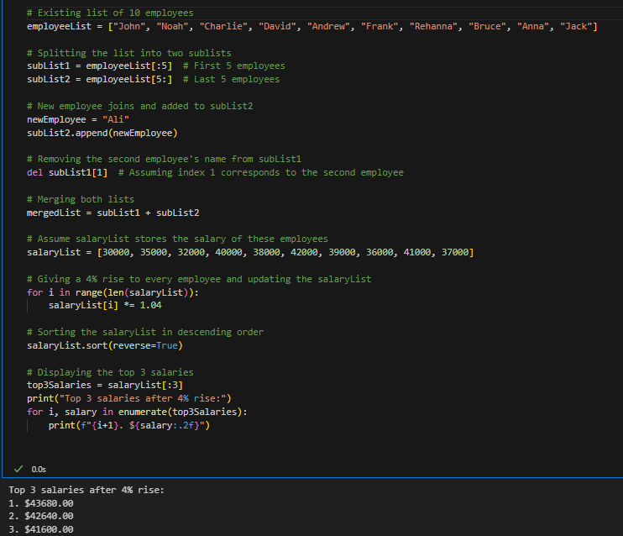

(b). Design a program such that it converts a sentence into a wordlist. Reverse the wordlist then. Write the code and output for the same.

